***JETSON NANO DEVELOPER KIT***

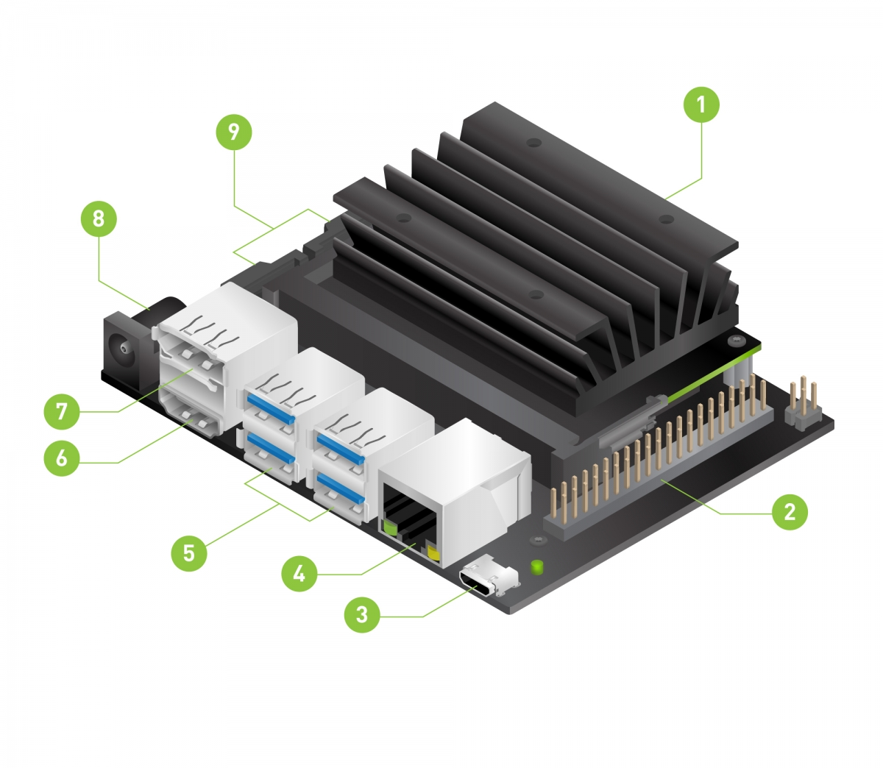

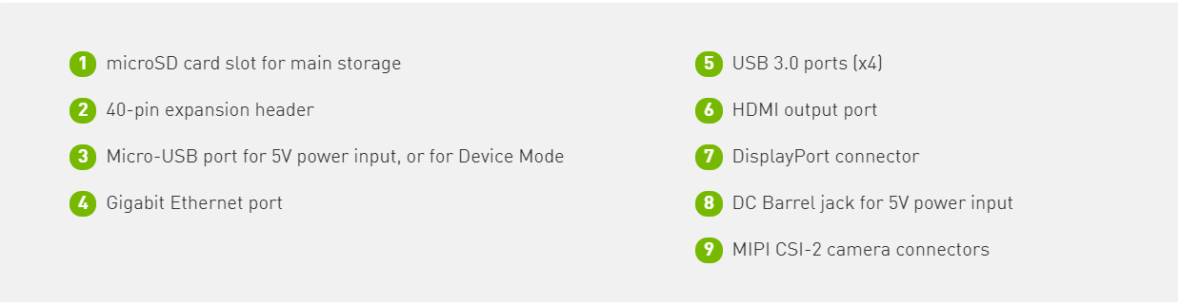

*NOTE - To enable use of the DC barrel jack power supply, you will need to fit a jumper to J48 on the Jetson Nano Developer Kit baseboard.

**STEP 1: -**

Insert memory card into memory card reader and then format memory using NTFS which is not the default format for memory card. FAT32 is the default format but FAT32 only allows max 4GB data transfer to memory card so change format to NTFS.

**STEP 2: -**

Download jetson-nano-jp45-sd-card-image this zipped folder is to be flashed to the memory card.

**STEP 3: -**

Download, install, and launch [Etcher](https://www.balena.io/etcher). Click “Select image” and choose the zipped image file downloaded earlier. Just don’t copy image in the memory card as target cannot contain image that you need to be flashed. Click “Select target” and choose the SD Card and the click on Flash. It will take about 10 minutes for Etcher to write image and validate the image.

**STEP 4: -**

Unfold the paper stand and place inside the developer kit box.

**STEP 5: -**

Insert the microSD card (with system image already written to it) into the slot on the underside of the Jetson Nano module.

**STEP 6: -**

Set the developer kit on top of the paper stand. Power on your computer display and connect it. Connect the USB keyboard and mouse.

**STEP 7: -**

Connect your Micro-USB power supply. The developer kit will power on and boot automatically. If the developer kits boots up and shuts down and the light goes out the problem is with the power supply jetson developer kit requires a consistent power supply of at least 4.75V check the cord connecting power supply to developer kit problems in the cord may also cause jetson developer kit to shut down.

